KUBENETES TASK O4

Deploy an application using a Deployment with 3 replicas and a rolling update strategy.
Create a yaml file
# vi rollingupdate.yml

apiVersion: apps/v1
kind: Deployment
metadata:
name: my-app-deployment
spec:
replicas: 3
strategy:
type: RollingUpdate
rollingUpdate:
maxSurge: 1
maxUnavailable: 1
selector:
matchLabels:
app: my-app
template:
metadata:
labels:
app: my-app
spec:
containers:
- name: my-app-container
image: nginx:latest
ports:
- containerPort: 80
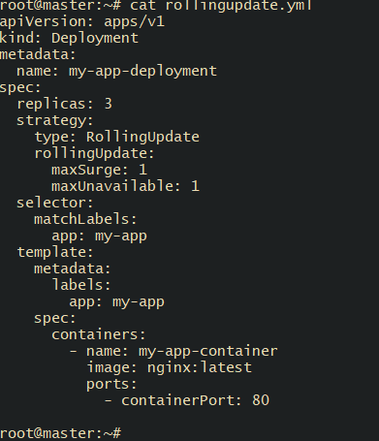
- kubectl apply -f rollingupdate.yml
- kubectl rollout status deployment my-app-deployment
- kubectl get pods -l app=my-app
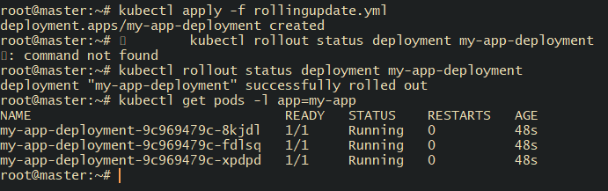

Configure a Deployment with a Recreate strategy and observe the downtime.
# vi nginx-recreate.yaml
apiVersion: apps/v1
kind: Deployment
metadata:
name: nginx-recreate
spec:
replicas: 3
strategy:
type: Recreate
selector:
matchLabels:
app: nginx
template:
metadata:
labels:
app: nginx
spec:
containers:
- name: nginx
image: nginx:1.24
ports:
- containerPort: 80

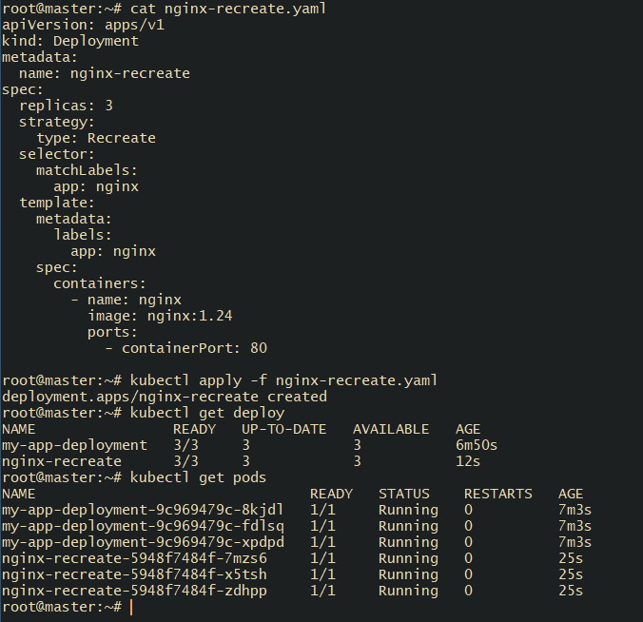
# kubectl apply -f nginx-recreate.yaml
# kubectl get deploy
# kubectl get pods


# kubectl expose deployment nginx-recreate -- type=NodePort --port=80
# kubectl get svc nginx-recreate
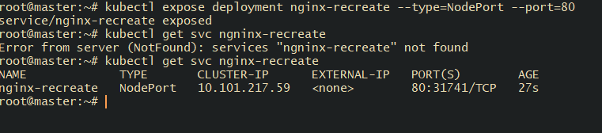

Check on your browser with workers ip and port number 31741

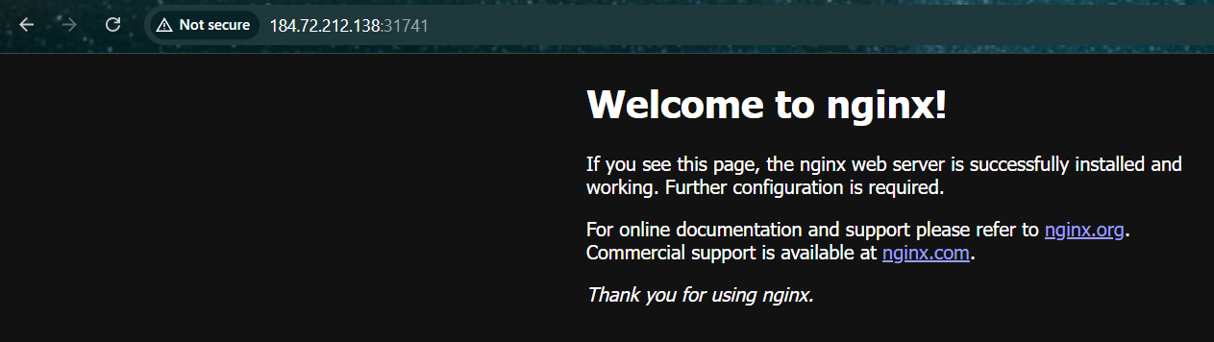

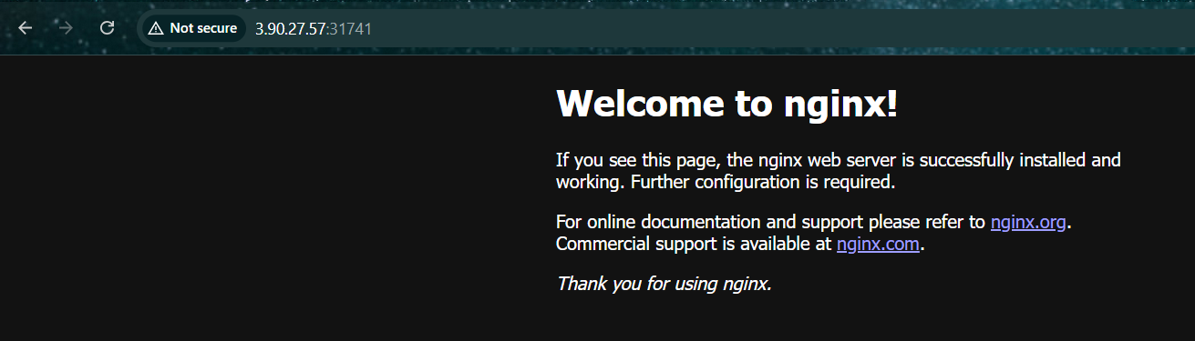

Watch the running pods # kubectl get pods -w
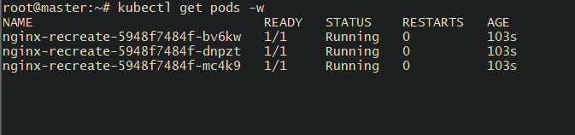
open another terminal and login same master machine and
perform this.
# kubectl set image deployment/nginx-recreate nginx=nginx:1.25
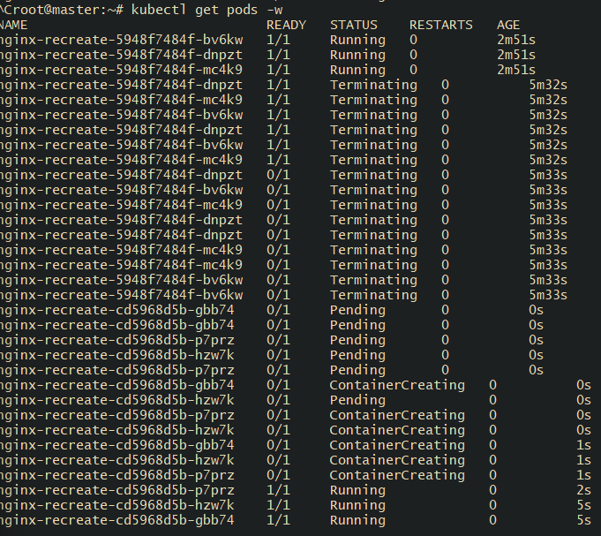

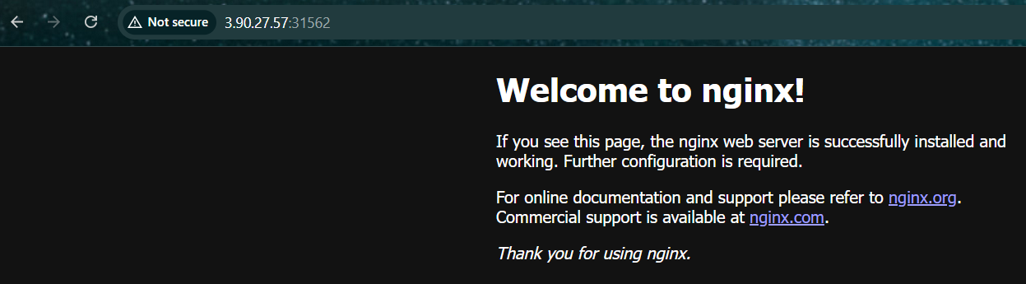

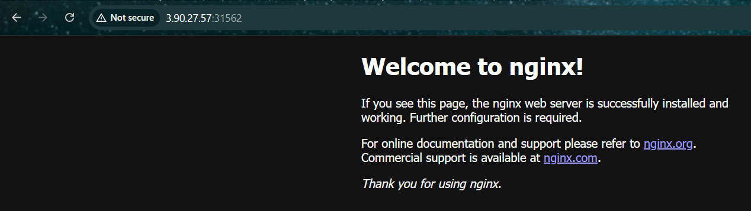

Update an existing Deployment and perform a rollback to the previous version.
# kubectl get deployments
# kubectl get deployments nginx-recreate -o wide

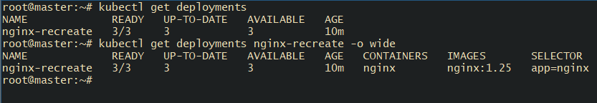

# kubectl rollout history deployment nginx-recreate

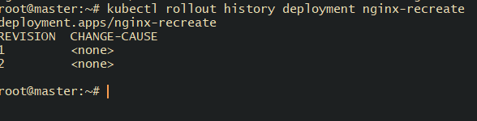

# kubectl rollout undo deployment nginx-recreate
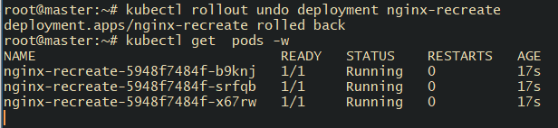

# kubectl rollout history deployment nginx-recreate

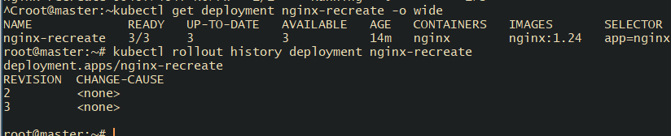

Modify a Deployment to add resource requests and limits for CPU and memory.
# vi nginx-resources.yaml
apiVersion: apps/v1
kind: Deployment
metadata:
name: nginx-resources
spec:
replicas: 3
strategy:
type: RollingUpdate
selector:
matchLabels:
app: nginx
template:
metadata:
labels:
app: nginx
spec:
containers:
- name: nginx
image: nginx:1.25
ports:
- containerPort: 80
resources:
requests:
cpu: "100m"
memory: "128Mi"
limits:
cpu: "200m"
memory: "256Mi"

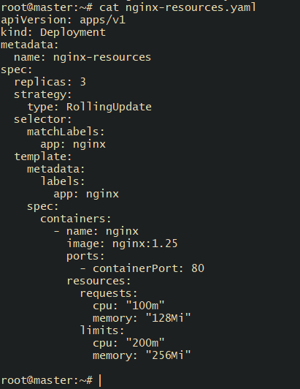
# kubectl apply -f nginx-resources.yaml
# kubectl get deployment nginx-resources
# kubectl get pods
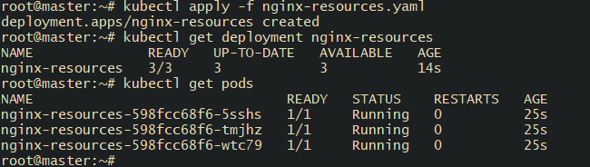

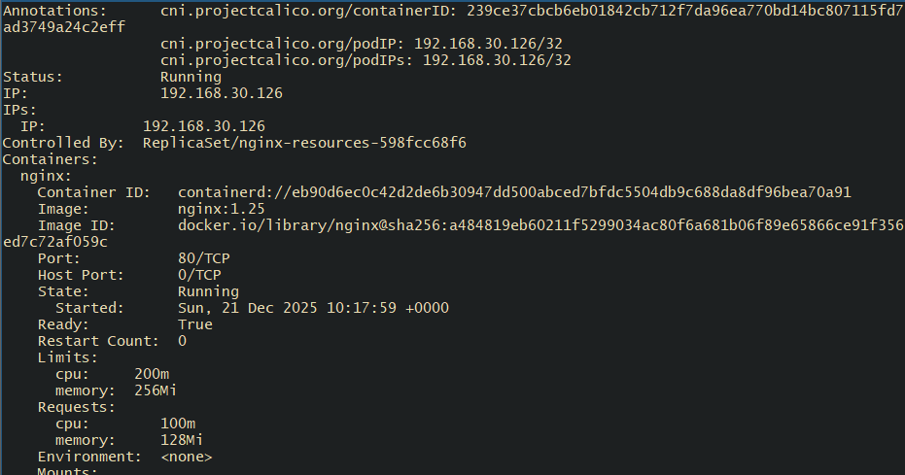

Create a Deployment with MaxSurge and MaxUnavailable configurations.
# vi nginx-rollling.yml
apiVersion: apps/v1
kind: Deployment
metadata:
name: nginx-rolling
spec:
replicas: 4
strategy:
type: RollingUpdate
rollingUpdate:
maxSurge: 1
maxUnavailable: 1
selector:
matchLabels:
app: nginx
template:
metadata:
labels:
app: nginx
spec:
containers:
- name: nginx
image: nginx:1.25
ports:
- containerPort: 80

# kubectl apply -f nginx-rolling.yaml
# kubectl get deployment nginx-rolling
# kubectl describe deployment nginx-rolling
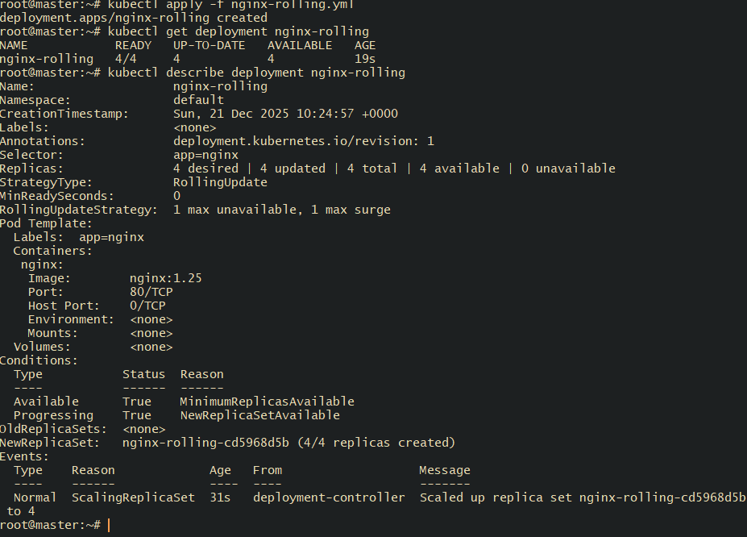
# kubectl set image deployment/nginx-rolling nginx=nginx:1.26
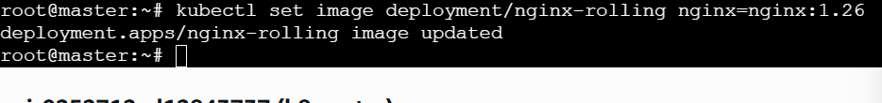

# kubectl get pods -w observe the pods in other terminal
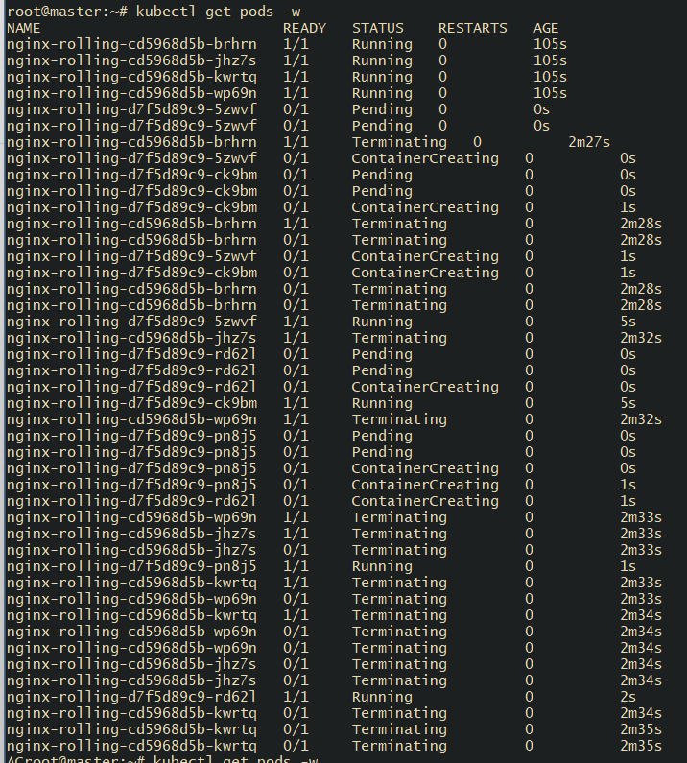

Set up a Deployment with a custom revision history limit.
# vi nginx-revision-limit.yml
apiVersion: apps/v1
kind: Deployment
metadata:
name: nginx-revision-limit
spec:
replicas: 3
revisionHistoryLimit: 2
strategy:
type: RollingUpdate
rollingUpdate:
maxSurge: 1
maxUnavailable: 1
selector:
matchLabels:
app: nginx
template:
metadata:
labels:
app: nginx
spec:
containers:
- name: nginx
image: nginx:1.25
ports:
- containerPort: 80
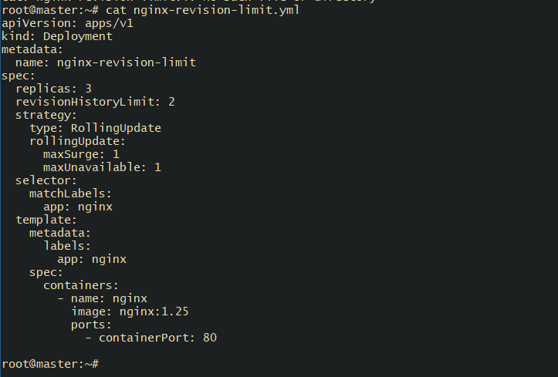

# kubectl apply -f nginx-revision-limit.yaml
# kubectl describe deployment nginx-revision-limit
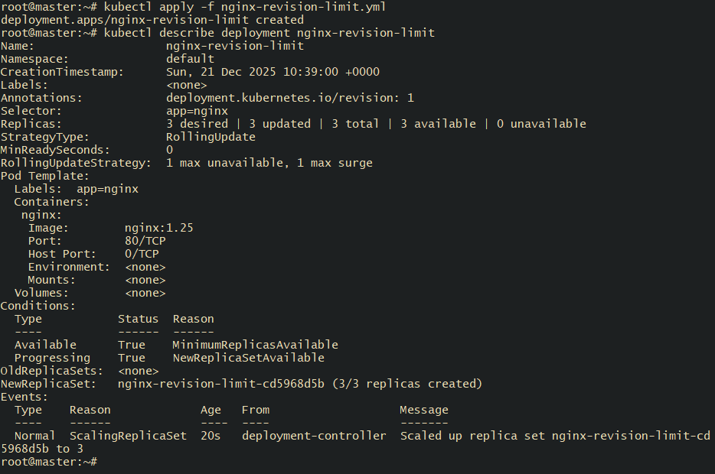

Update the image multiple times
# kubectl set image deployment/nginx-revision-limit nginx=nginx:1.26
# kubectl set image deployment/nginx-revision-limit nginx=nginx:1.27kubectl get
# kubectl set image deployment/nginx-revision-limit nginx=nginx:1.28
# kubectl get rs
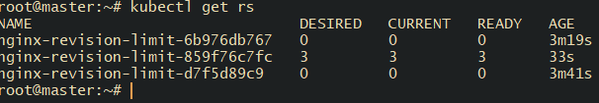

. Pause a Deployment during an update and then resume it.
Use nginx-rolling yamlfile and update the image to 1.25
# kubectl set image deployment/nginx-rolling nginx=nginx:1.25
# kubectl rollout pause deployment nginx-rolling
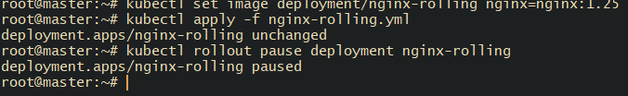
# kubectl rollout resume deployment nginx-rolling
# kubectl rollout status deployment nginx-rolling
#kubectl get pods
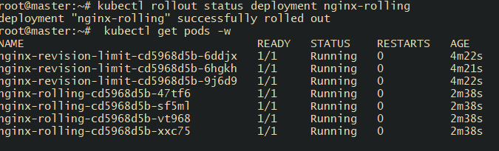

Create a pod using resource requests for memory and CPU and observe how the scheduler assigns it to a node.
# vi resource-pod.yml

apiVersion: v1
kind: Pod
metadata:
name: resource-pod
spec:
containers:
- name: nginx
image: nginx
resources:
requests:
cpu: "500m"
memory: "256Mi"
limits:
cpu: "1"
memory: "512Mi"
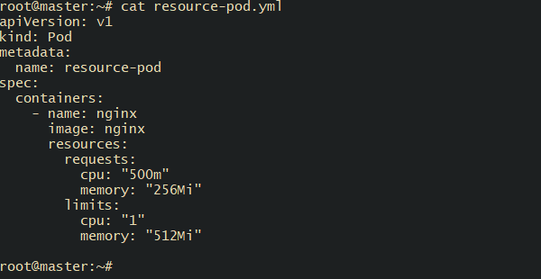

# kubectl apply -f resource-pod.yaml
# kubectl get pod resource-pod -o wide
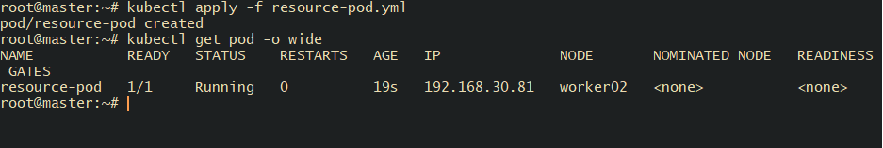

# kubectl describe pod resource-pod

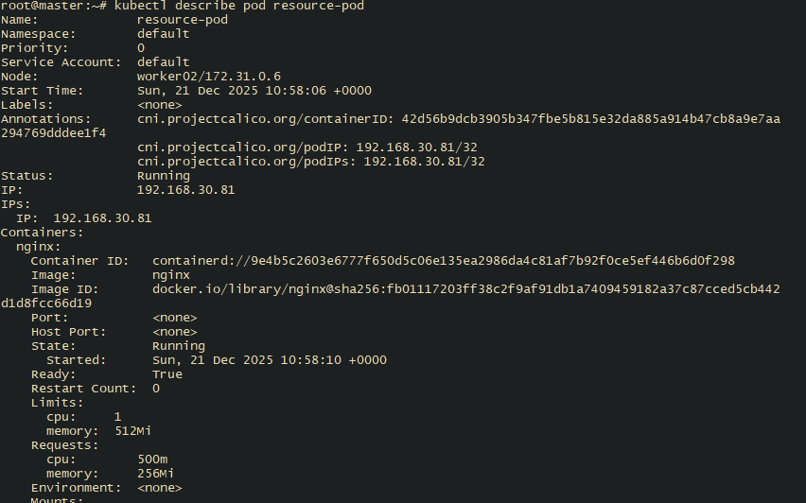

# kubectl describe node worker-02

